OpenRefine exercises - From excel to OpenRefine

Start OpenRefine + Import excel file into OpenRefine

Start OpenRefine
The program opens a terminal. Keep the terminal open.

The program opens in your standard browser. To start OpenRefine in another browser, copy the link (red square) and paste it into another browser.

Import excel file into OpenRefine: Create project ① > This Computer ② > Choose files ③ > Next ④
④
③
②
①

Define project: Project name ① > headers and blanks ② > Create Project ③
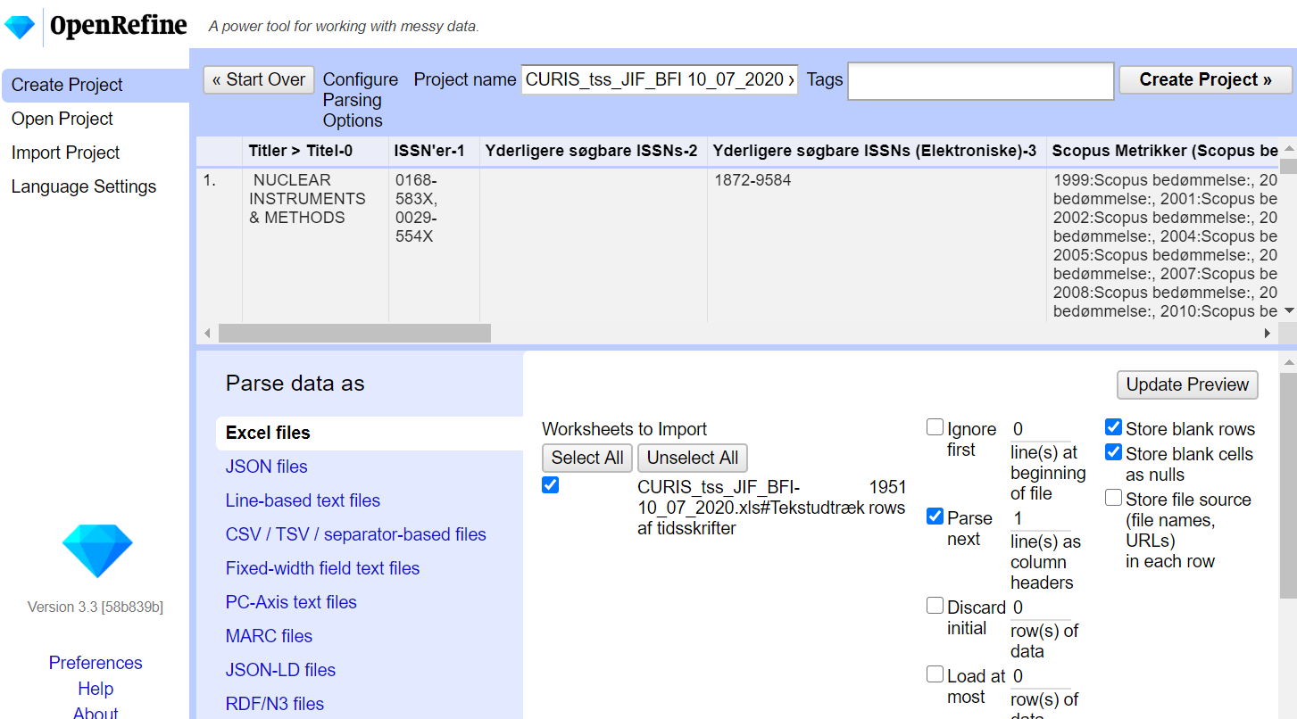
②
②
①
③

Operations in OpenRefine via graphical user interface – three exercises

Edit in cells: click edit ① > change content of cell ② > apply / apply to all identical cells ③
①

②
③

Edit cells via drop-down menus: click icon left of column header ① > edit cells ② > common transforms ③ > click one ④
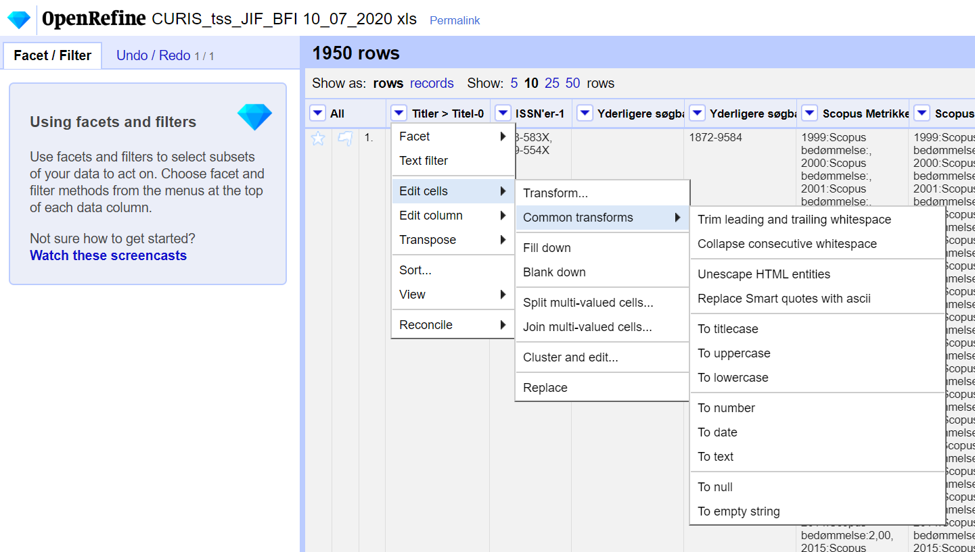
①
②
③
④

Edit cells via facets: click icon left of column header ① > facet ② > click one ③
①
②
③

Edit cells via facets (continued):
edit ① > change content of cell(s) in pop-up window ② > Apply ③

OR

Cluster ①
②
①  ① | ③

Edit cells via facets: Cluster (continued) > select Merge ② > Merge Selected & Close ③
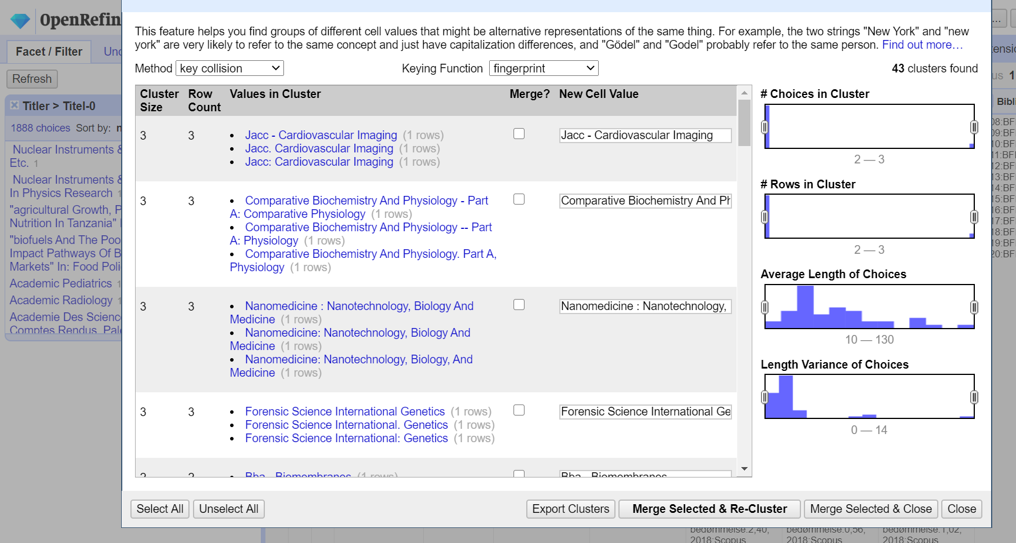
②
③

Operations in OpenRefine via non-graphical user interface

Move column: click icon left of column header ① > Edit column ② > Move column right ③
③
②
①

Reuse operation to move column: click Undo / Redo ① > Extract… ②
①
②

Reuse operation to move column (continued): select the last operation ③ > copy text ④ > Close ⑤
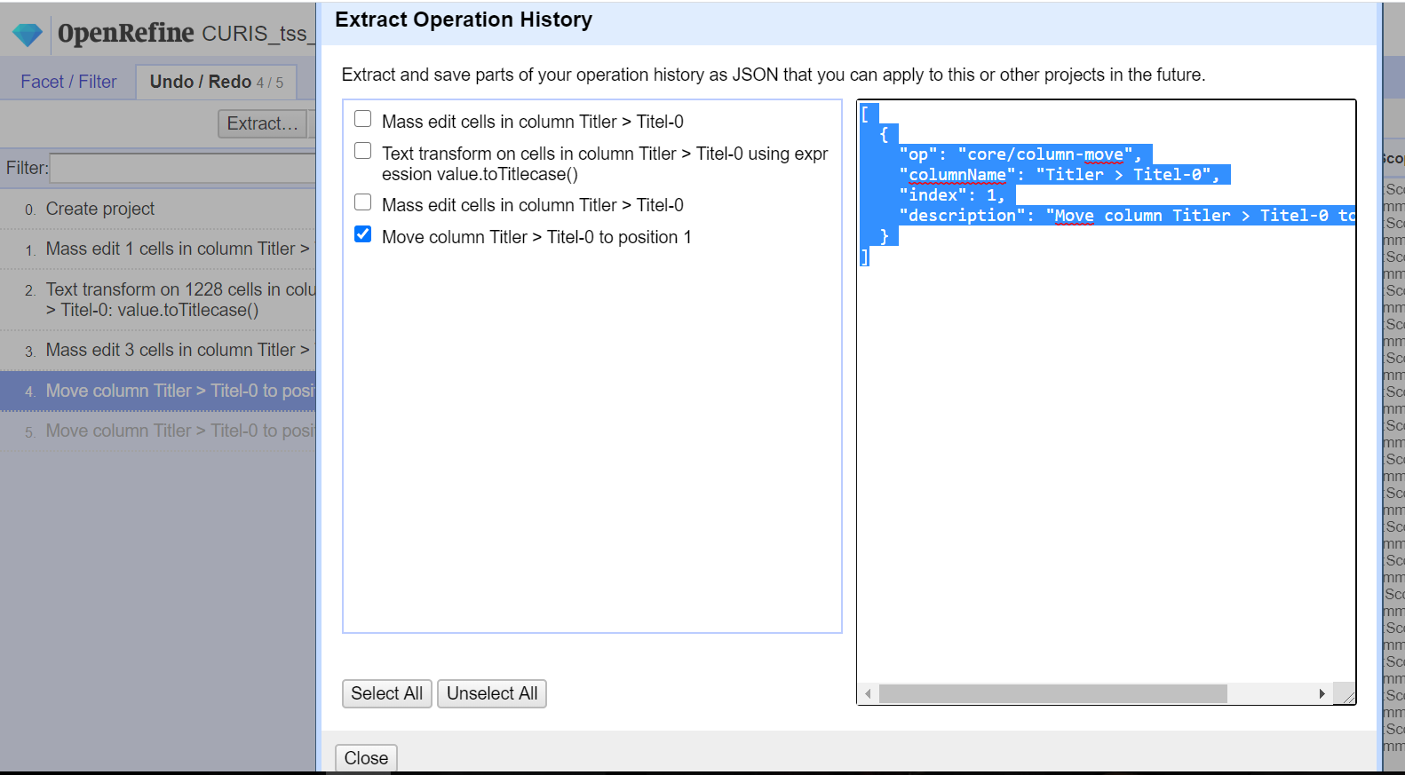
⑤
④
③

Reuse operation to move column (continued): Apply… ⑥
⑥

Reuse operation to move column (continued): Paste text ⑦ > change index number ⑧ > Perform Operations ⑨
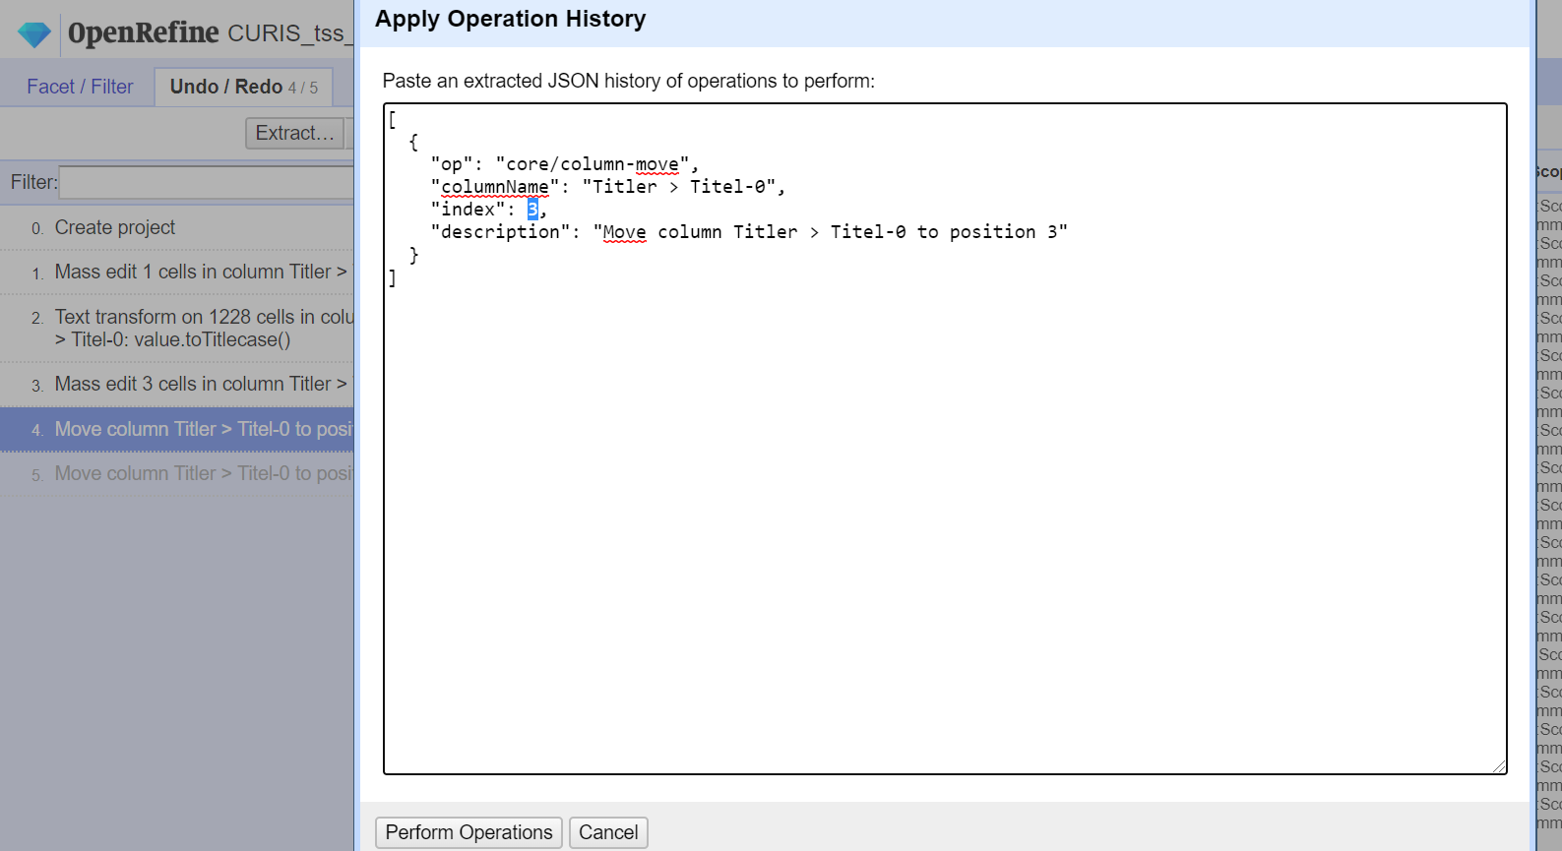
⑨
⑧
⑦

The column has been moved ⑩
⑩

Reuse expression to edit cells: click Undo / Redo ① > Extract… ② > select the second operation (operation includes “expression value.”) ③ > copy text in “ ” starting with value. ④ > Close ⑤
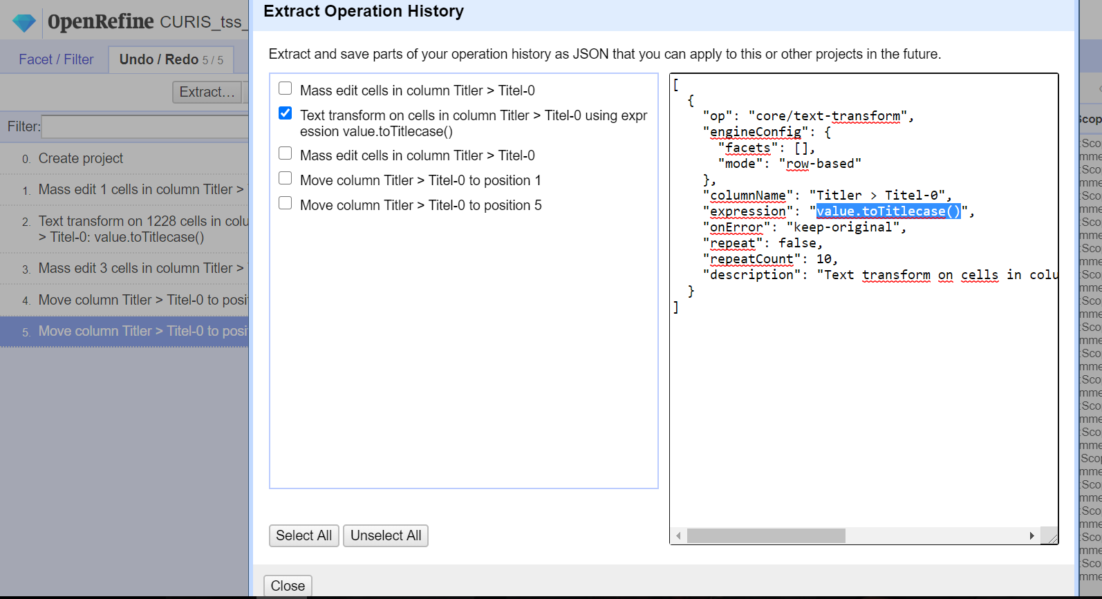
⑤
④
③
②
①

Reuse expression to edit cells (continued): click icon left of a column header ⑥ > Edit cells ⑦ > Transform… ⑧
⑧
⑦
⑥

Reuse expression to edit cells (continued): Paste text ⑨ > OK ⑩
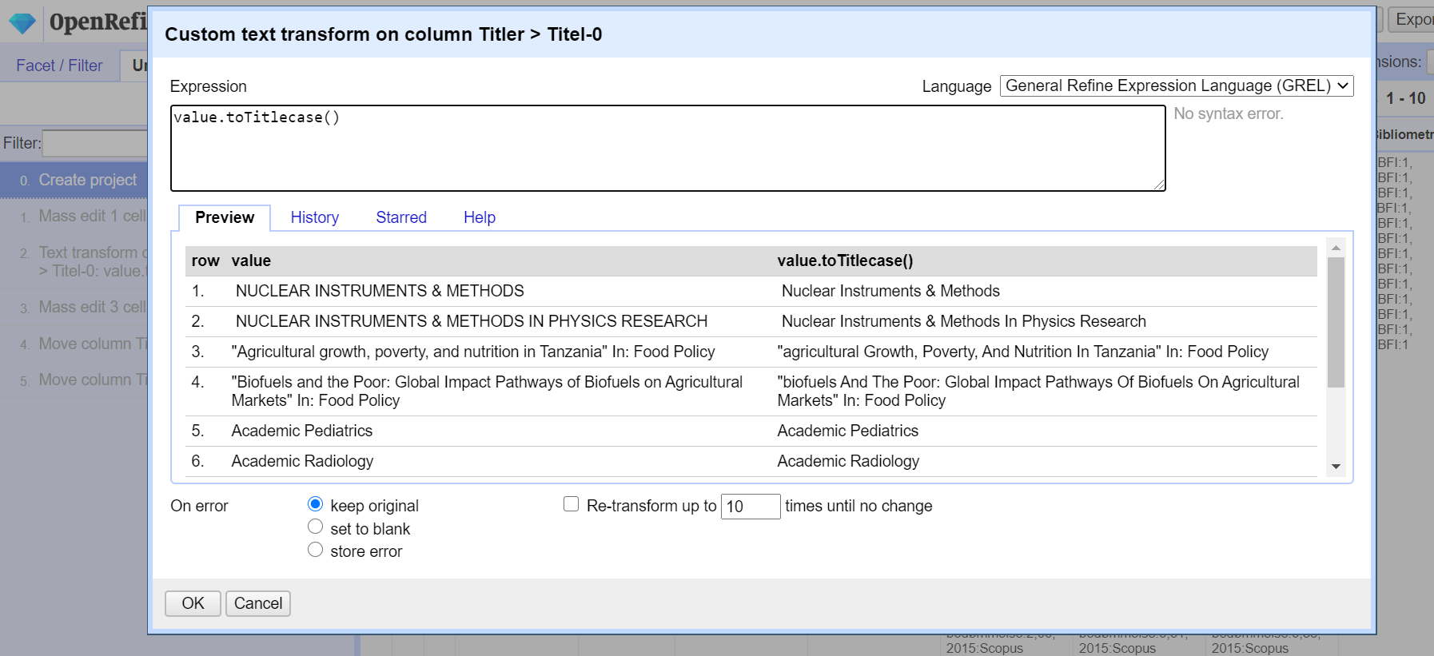
⑩
⑨

The cell values have been changed ⑪
⑪

Export from OpenRefine into excel file

Export from OpenRefine into excel file: Export ① > Excel / Excel 2007+ ②
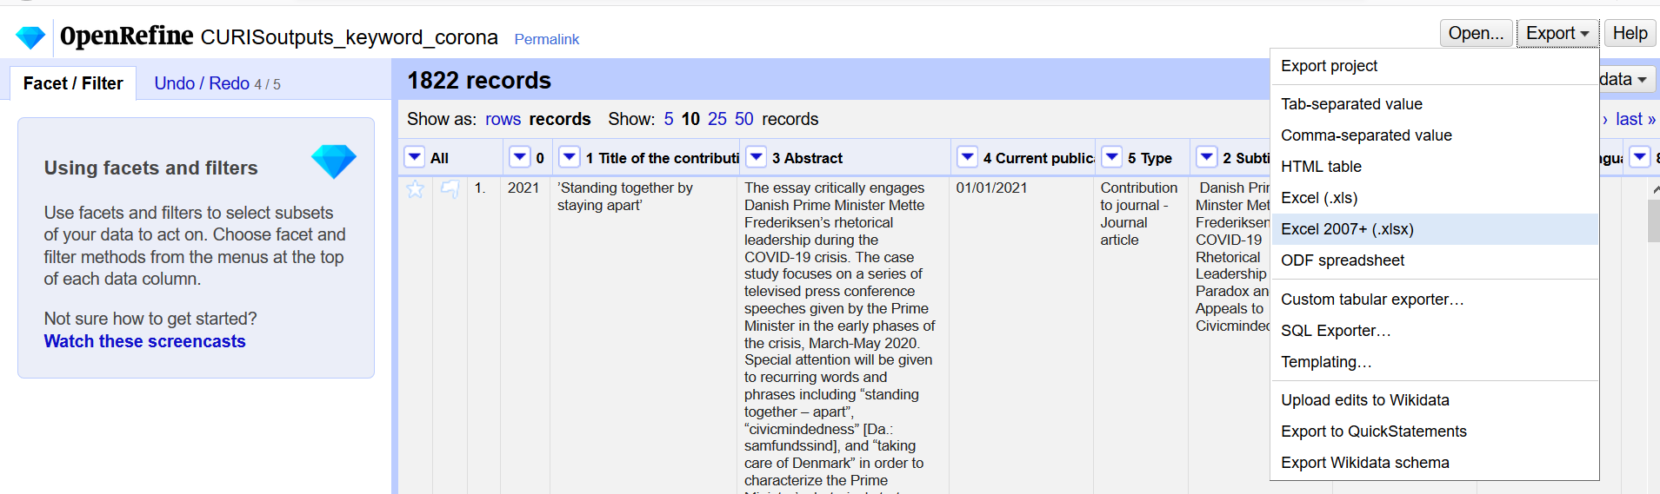
②
①

Export from OpenRefine into excel file (continued): click OK ③
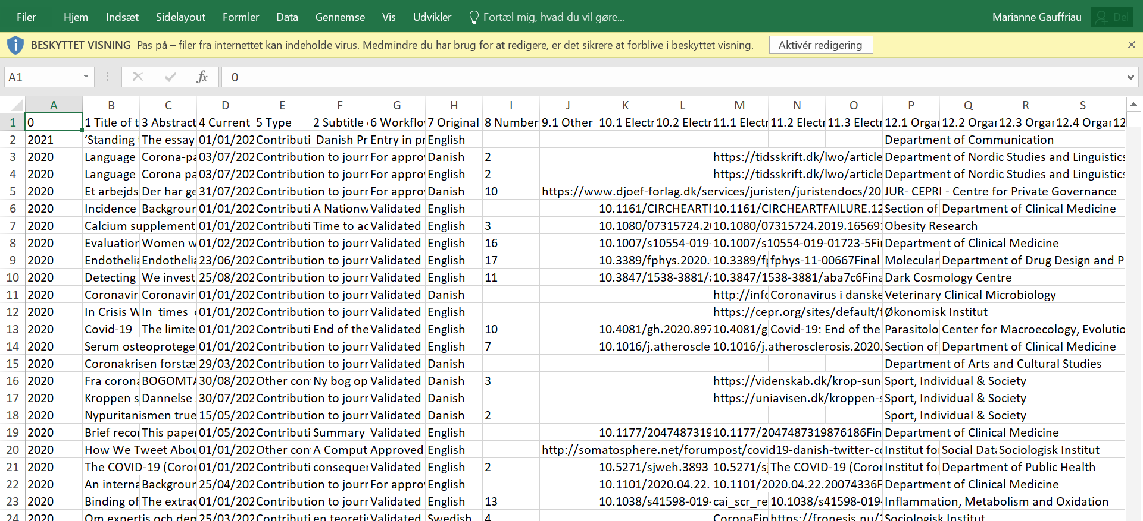
③

